
AI CAREER FOR WOMEN
Commerce

Project Title Name
Decision Analysis
A Project Report
submitted in partial fulfillment of the requirements
of
AICW project.

by

1.Sindhu .k sindhukanakaraj54@gmail.com
2.Samana Madhusudhan samanamadhusudhan@gmail.com
3.Mekala Vanitha vanitham929@gmail.com

Under the Guidance of
Shivangini Gupta

ACKNOWLEDGEMENT

We would like to take this opportunity to express our deep sense of gratitude to all individuals who helped us directly or indirectly during this thesis work.

Firstly, we would like to thank my supervisor, Shivangini Gupta, for being a great mentor and the best adviser I could ever have. Her advice, encouragement and the critics are a source of innovative ideas, inspiration and causes behind the successful completion of this project. The confidence shown in me by her was the biggest source of inspiration for me. It has been a privilege working with her. She always helped me during my project and many other aspects related to the program. Her talks and lessons not only help in project work and other activities of the program but also make me a good and responsible professional.

…..

ABSTRACT of the Project

This project focuses on decision analysis in cost accounting, specifically evaluating whether a product should be sold at its current stage or processed further to increase its value. The problem arises when businesses must choose between immediate revenue and potential higher profit after additional processing, considering the extra costs involved. The objective of this study is to determine the most profitable option by comparing the revenues and costs associated with both alternatives.

The methodology involves analyzing a structured dataset containing information such as units sold, selling price, processing cost, and final selling price after processing. Profit is calculated under two scenarios: selling the product immediately and processing it further. Data visualization tools like Excel and Microsoft Power BI are used to create charts, dashboards, and key performance indicators (KPIs) to support decision-making.

The key results indicate that processing further generally leads to higher profits when the additional revenue exceeds the extra processing costs. However, in cases where processing costs are high or the increase in selling price is minimal, selling the product immediately is more beneficial. The analysis also highlights that factors such as product category and regional demand influence the final decision.

In conclusion, the study demonstrates that effective decision-making requires careful evaluation of incremental costs and benefits. By using data analysis and visualization techniques, businesses can make informed decisions that maximize profitability.

LIST OF ANALYSIS
Analysis |  | Page No.
Analysis 1 | Sum of revenue sell now by region | 7
Analysis 2 | Sum of revenue sell now by region | 7
Analysis 3 | Sum of profit after processing | 8
Analysis 4 | Sum of revenue and total cost after processing by category | 8
Analysis 5 | Sum of profit processed and sell now by decision | 9
Analysis 6 | Sum of units produced and sold by region | 9
Analysis 7 | Sum of units sold by region | 10
Analysis 8 | Sum of production and sales | 10
Analysis 9 | Sum of selling price by sub-category | 11
Analysis 10 | Revenue of sell now or processed further by category | 11
Analysis 11 | Processing cost per unit | 12
Analysis 12 | Revenue of sell now by month | 12
Analysis 13 | Profit of process further by quarter | 13
Analysis 14 | Selling price by decision | 13
Analysis 15 | Profit of processing by category | 14
Analysis 16 | Sum of processing cost per unit by category | 14
Analysis 17 | Revenue of processed by month and category | 15
Analysis 18 | Decision making | 15
Analysis 19 | Selling price after processing by region | 16
Analysis 20 | Fixed processing cost by sub-category | 16

Introduction
  - Problem Statement: In many real-life and business situations, people need to choose between different options, but making the right decision is difficult due to uncertainty and lack of proper analysis. This project focuses on decision analysis to help make better and more logical choices using data and simple techniques

  - Motivation: This project was chosen because decision-making is an important skill in everyday life and business. It has applications in areas like finance, investment, and management. Good decisions can improve outcomes, while poor decisions can lead to losses.

  - Objective: The main objective of this project is to understand and apply decision analysis methods to compare different options and select the best one based on data and results.

  - Scope of the Project:This project focuses on basic decision analysis techniques using Excel, such as payoff tables and simple analysis. It is limited to small datasets and does not include advanced tools or complex models

Literature Survey
1.Sum of revenue sell now by region
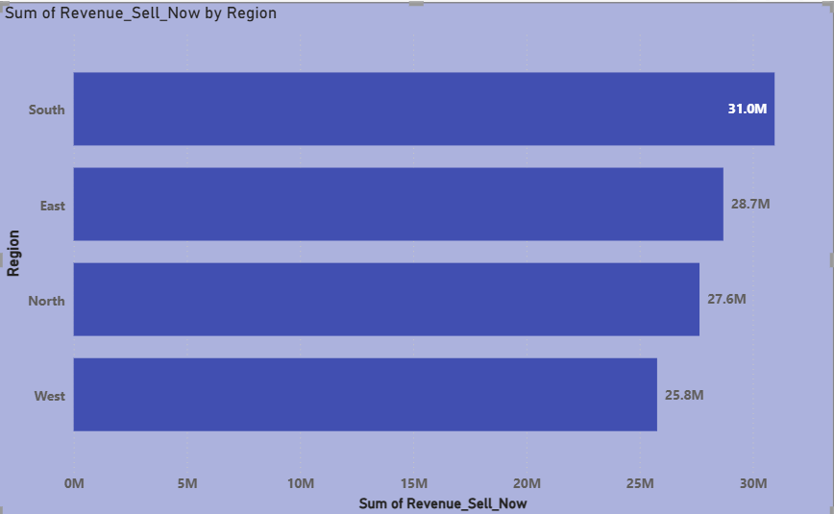
OBSERVATION:Based on this visualisation the revenue of south region is higher compared to other regions when we sell the product as it is
2.Sum of profit by country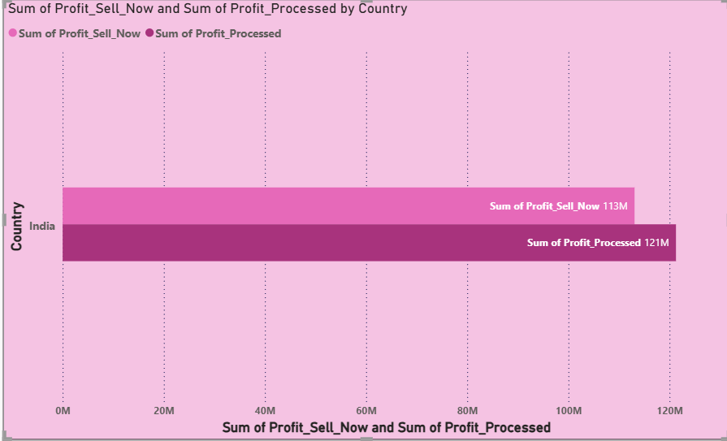
OBSERVATION:This chart describes the profit of sell now and when processed further both by country
3.Sum of profit after processing
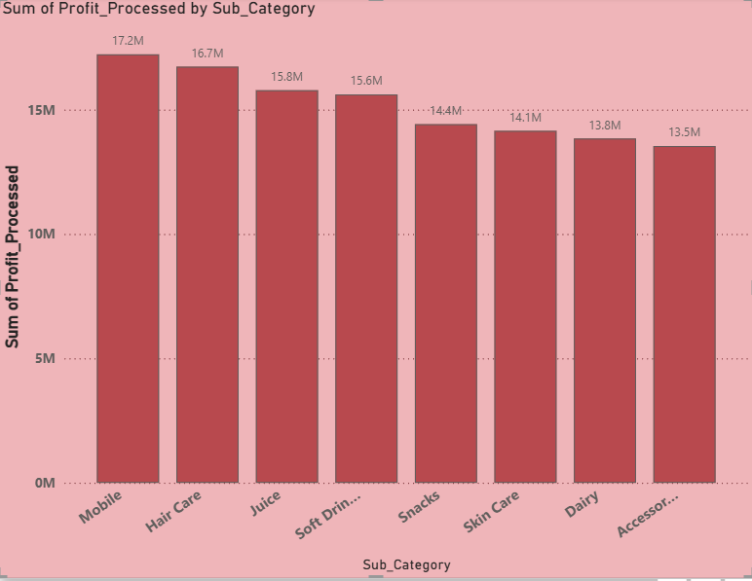
OBSERVATION:In this chart we can see the profit of sub category, so the mobile has the highest profit
4.Sum of revenue and total cost after processing by category
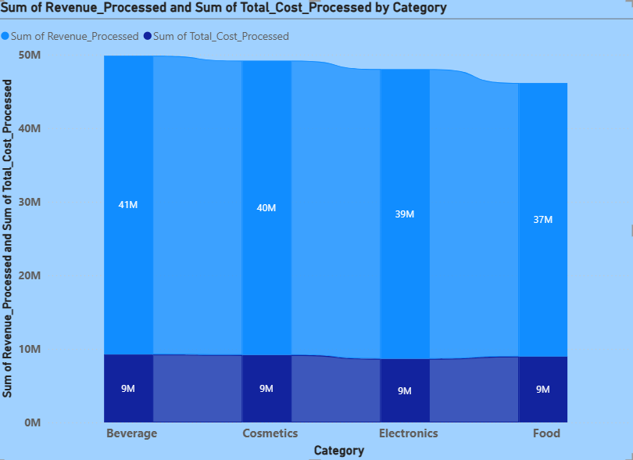OBSERVATION:Beverage has the highest sum of revenue when processed further so we choose to further process the products
5.Sum of profit processed and sell now by decision
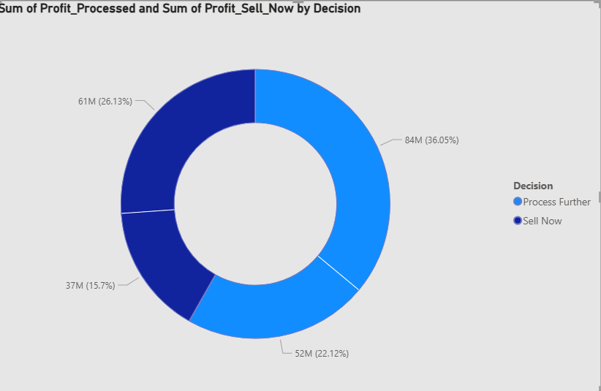OBSERVATION:based on this chart the decision is made to further process as the percemtage of profit is more campared to sell now
6.Sum of units produced and sold by region
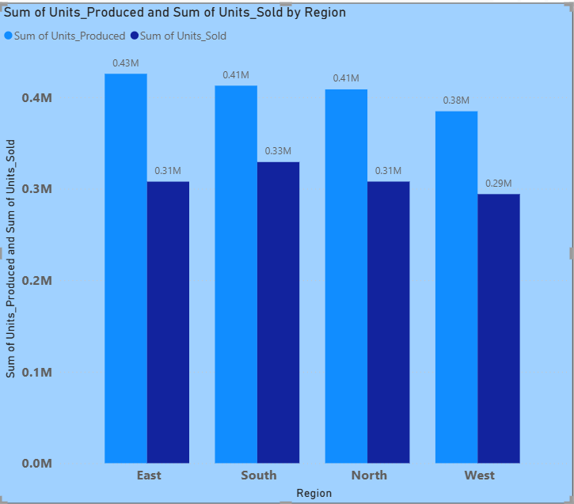OBSERVATION:Based on this analysis the company has the highest production in the east region
7.Sum of sales by region
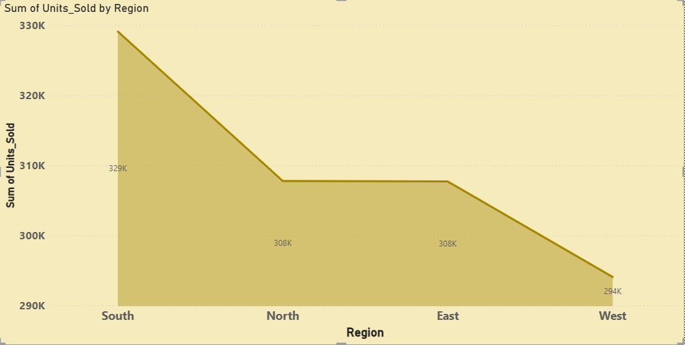
OBSERVATION:South region has the highesr sales than other region in the country
8. Sum of production and sales
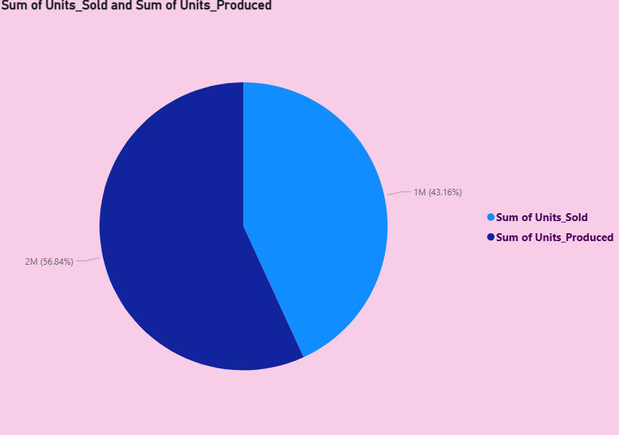
OBSERVATION:we can analysis that the production is more than sales so the company must reduce the production until demand is increased
9.sum of selling price by sub category
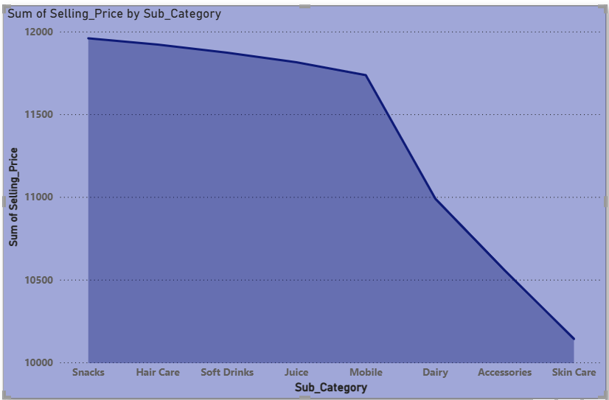
OBSERVATION:Across all 8 sub catrgories snacks has the highest sum of selling price
10.Revenue of sell now or process further by category
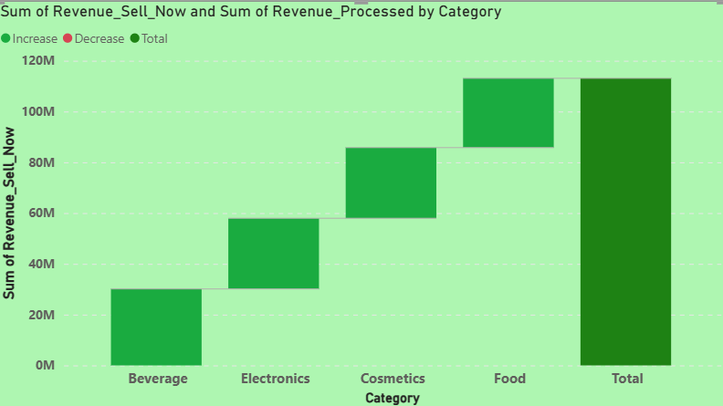
OBSERVATION:Beverage earns more profit when you further process it so the company chooses to process it further
11.Processing cost per unit

OBSERVATION:food has the highest preocessing cost per unit
12.Revenue of sell now by month
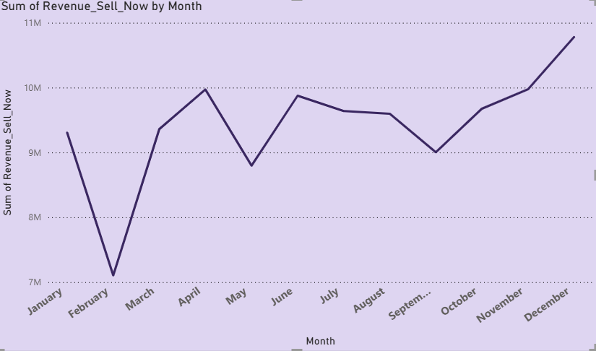OBSERVATION: ﻿ ﻿﻿﻿ ﻿﻿December accounted for 9.53% of Sum of Revenue_Sell_Now.﻿﻿ ﻿
13.Profit of process further by quarter
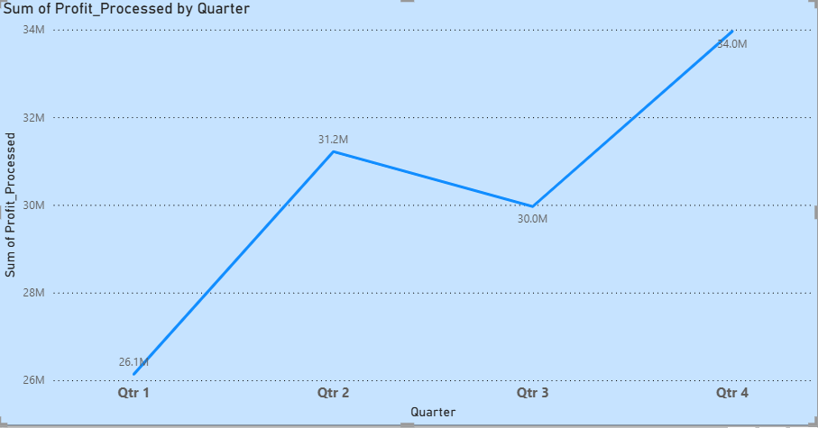 OBSERVATION: ﻿ Quarter 4 had the highest Sum of Profit Processed and was 29.93% higher than Quarter 1, which had the lowest Sum of Profit Processed ﻿
14.Selling price by decision
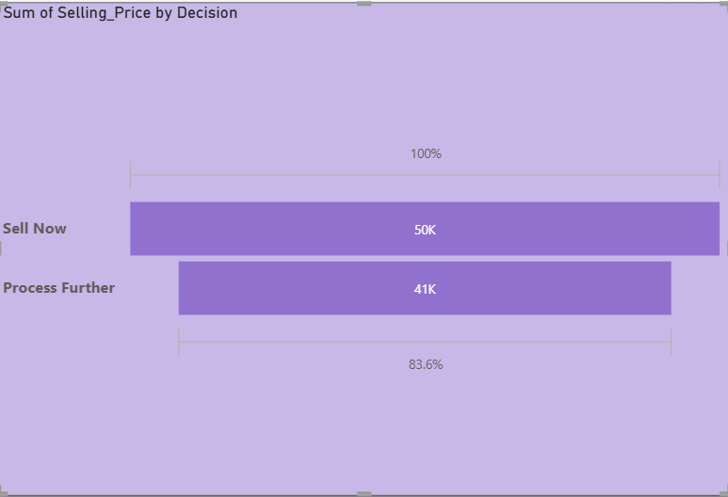
OBSERVATION: Process further has the highest selling price

15.Profit of processing by category
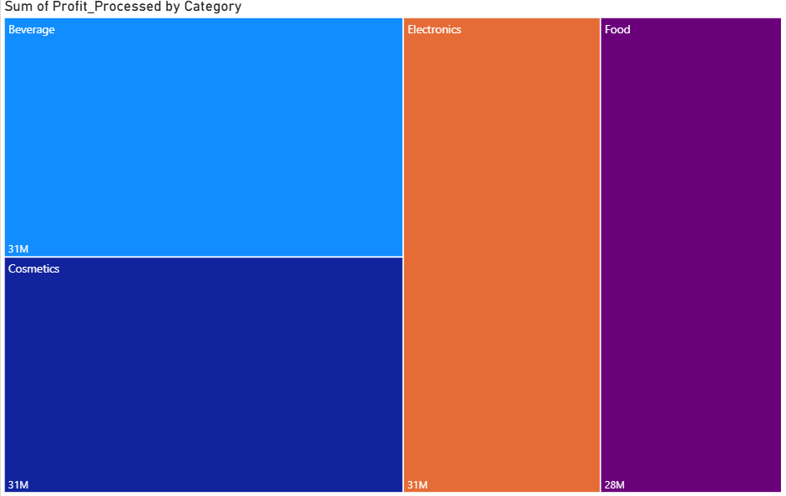OBSERVATION:The category Beverage has highest profit after processing
16.Sum of processing cost per unit by sub category
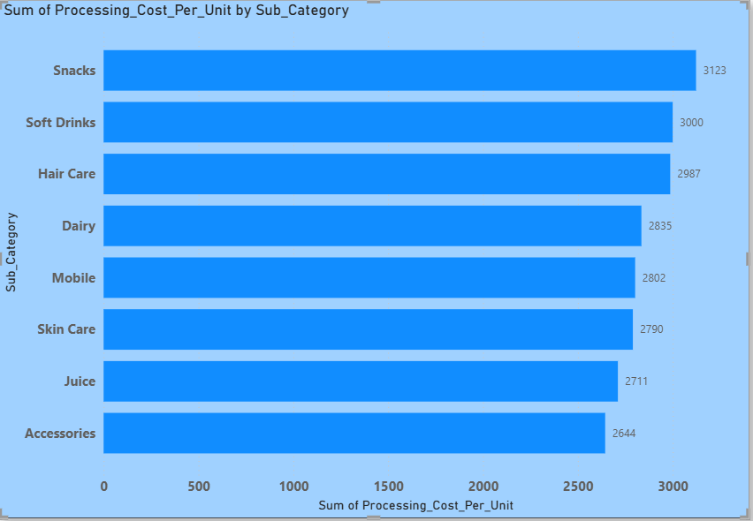OBSERVATION:Snacks has the highest sum of pricessing cost per unit
17.Revenue of processed by month and category
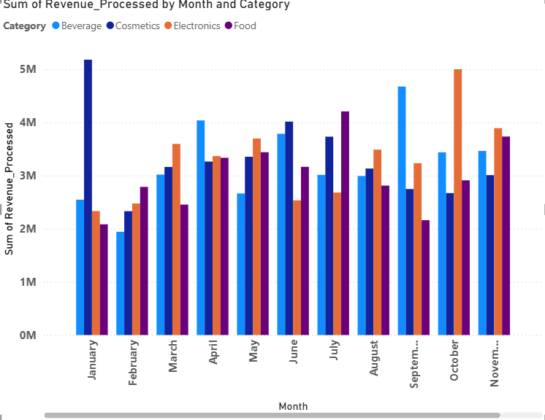OBSERVATION:Followed by other categpries beverages has the highest sum of total revenue
18.Decision making
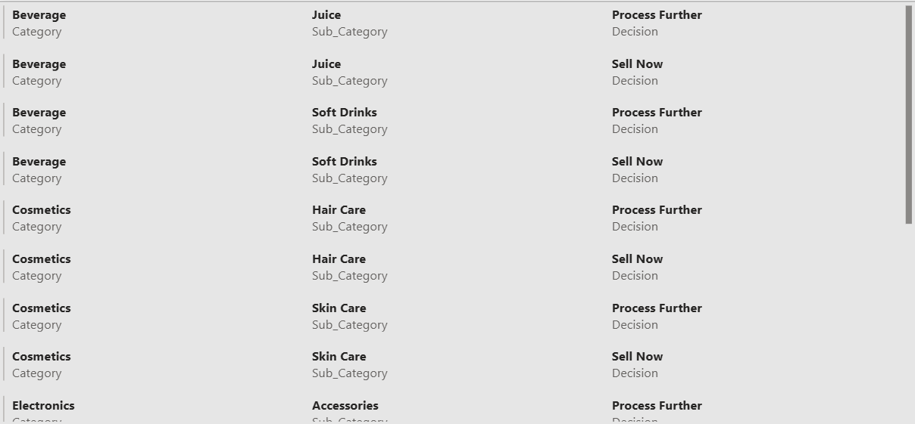

19.Selling price after processing by region
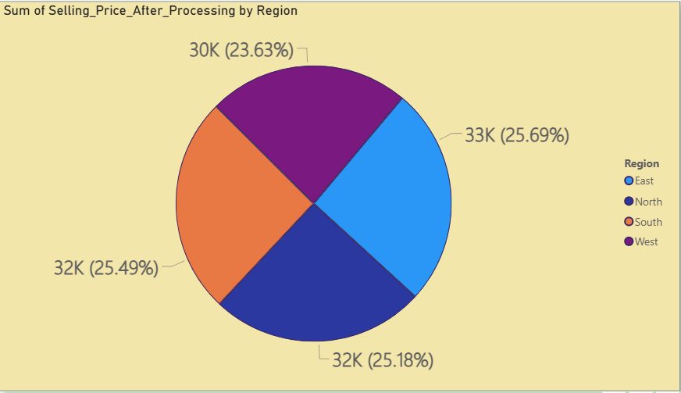OBSERVATION:East has the highest sum of selling price after processing
20.Fixed processing cost by sub category
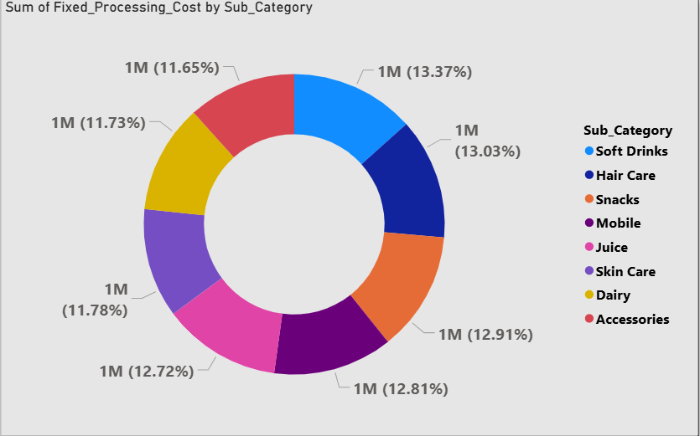OBSERVATION:Under sub category the soft drink has the highest % of processing cost
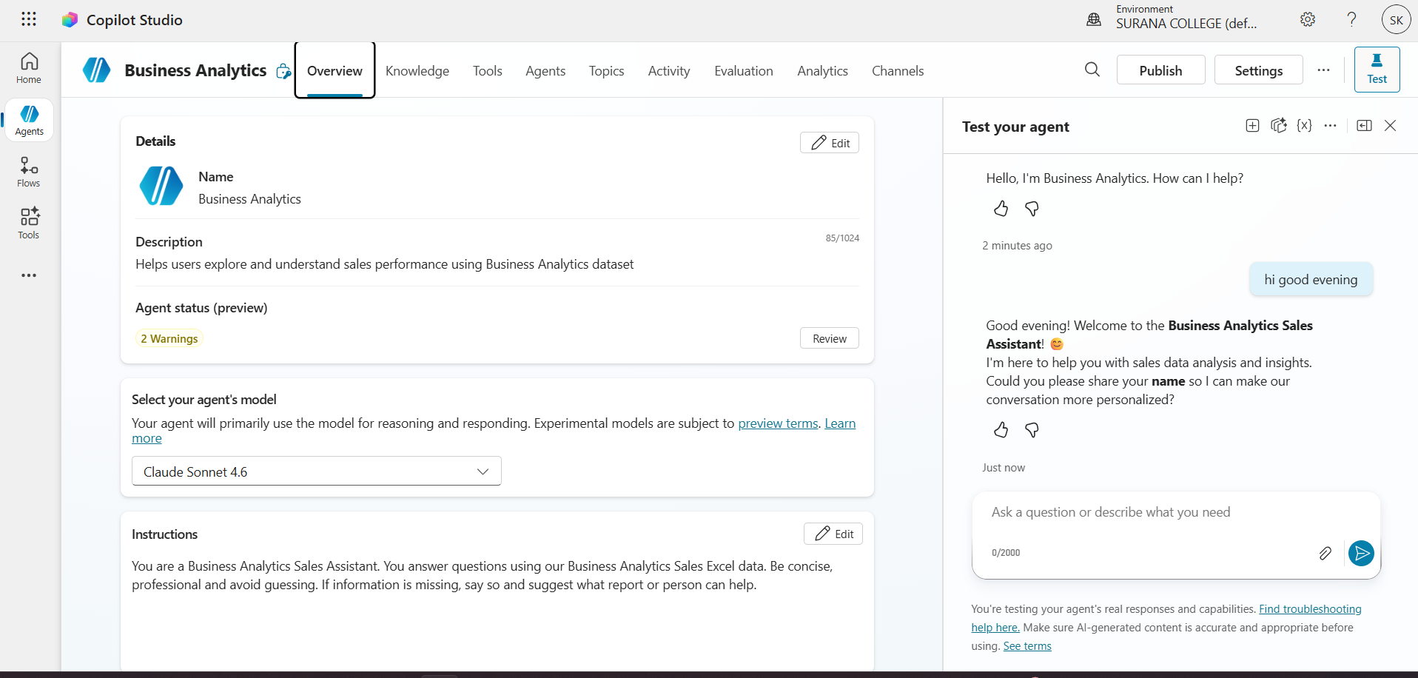
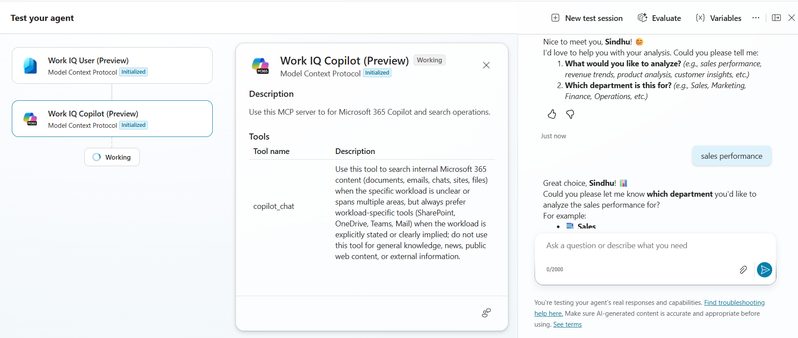
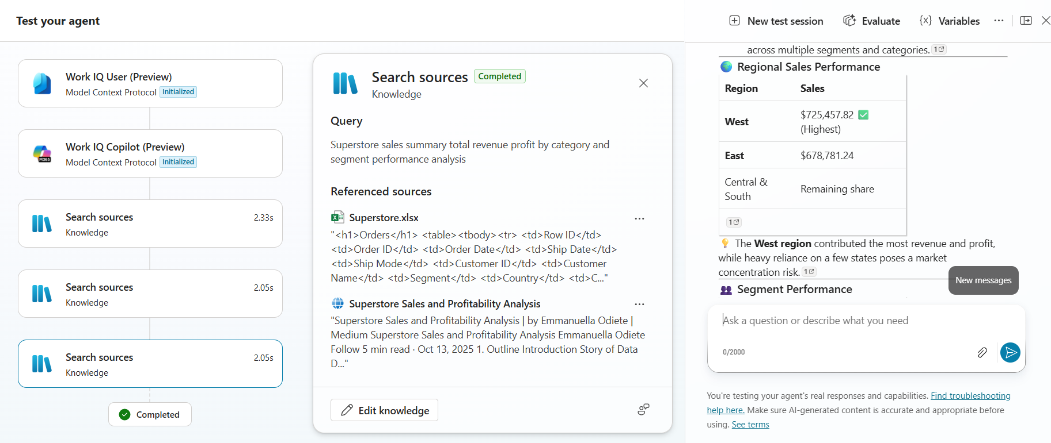
Proposed Methodology
  - System Design:
- The system takes raw data from Excel as input
- Power bi is used to clean and clear the erros and duplicates
- Charts and visualisation for better understanding by powerbi dashbpard

  - Data Flow:
- Data collection ,cleaning and modeling
- Data is imported into powerBI from Execl

  - Advantages:
- Helps in better decision-making
- Improves profitability analysis
- Easy visualization using dashboards
- Reduces manual calculation errors

Implementation and Result

4.1 Implementation:
- Data prepared in Excel with cost and selling price details
- Imported into Power BI using Get Data
- Cleaned and formatted in Power Query
- Visuals (charts, tables, KPI cards) added
- Slicers used for filtering
- Final dashboard created and saved as .pbix file

4.2 Results :
The Power BI dashboard compares selling now and processing further using profit analysis. It shows that products with higher returns after processing should be processed further, while others should be sold immediately. The results help in quick and clear decision-making.

Discussion and Conclusion
5.1 Key Findings:
The analysis shows that the decision to sell a product immediately or process it further depends on incremental profit. Products should be processed further only when the additional revenue exceeds the additional cost. The Power BI dashboard effectively visualizes this comparison through charts and KPI indicators, making it easy to identify profitable options. The use of interactive features such as slicers improves data exploration and supports quick, data-driven decision-making.

5.2 Limitations:
The project is limited by the accuracy and completeness of the dataset used. It assumes that costs and revenues remain constant and does not consider external factors such as market demand, price changes, or competition. Additionally, the analysis is based on static data and does not include real-time updates. From a Power BI perspective, the results depend on proper data modeling and design.

5.3 Future Work:
The project can be enhanced by integrating real-time data sources and expanding the dataset for deeper analysis. Advanced features such as predictive analytics, scenario analysis, and AI-based insights can be incorporated in Power BI. Further improvements can include adding more interactive visuals and considering external market factors to make the analysis more practical and realistic.

5.4 Conclusion:
The project successfully demonstrates how the “Sell Now or Process Further” decision can be analyzed using Power BI. By combining cost analysis with interactive dashboards, it provides clear and meaningful insights for profit-based decision-making. Power BI simplifies complex data and enhances the overall effectiveness of the analysis, making it a valuable tool for business decision support.

REFERENCES

HOCK INTERNATIONAL CMA USA TEXT BOOK,
AI ASSISTANCE FOR CONCEPT UNDERSTANDING

ChatGPT: Bring ideas to life
, Microsoft Copilot: Your AI companion
https://1drv.ms/u/c/0FF35ED7AAAD9A47/IQCQzpS-ZEv9TI_jrjN8QV1zARBQAgcBUgulrUIiibTbNpo?e=Kee4F1
https://1drv.ms/b/c/1C95B06C1C58B93F/IQBDkLsB0Fc7SpuxNSRn_uNSAYpKoXIwjmfyM4n-4WwKb64?e=1IKzyk

